**Locking and Security**

**3.4: LOCKING AND SECURITY [Neal Traynor]**

This section of the report will cover the design and mechanisms that will be used for the security of the Vehicle. The engineering question asked was "what is the best way to keep the security of the Vehicle as cheap and easy as possible, all the while performing the job that is required?" The engineering parameters used to answer this question were *durability, simplicity,* and *effectiveness.* By applying these three parameters it was determined that a two-tier approach would be sufficient in providing security for the Vehicle. The primary option was modifying the existing car door lock and incorporating it into the door of the recumbent tricycle. This would prevent unwanted access inside the interior of the Vehicle. The secondary option was using a common bike lock to keep the Vehicle attached to a pole or bike rack. This would prevent the Vehicle from being moved or taken away while the user is away.

**3.4.1: PRIMARY OPTION**

The primary option for security of the Vehicle was chosen to be a car door lock incorporated into the door of our Vehicle. This is the best option for preventing unwanted entry to the inside of the Vehicle because it encompasses all three of the engineering parameters defined earlier. The widespread use of the device would make it cheap and to acquire as many units as would be needed, and it would also mean that the product used in the Vehicle would be well tested for strength and effectiveness. A specific mechanism that was found was US Patent number 5 494 321[20](see figures ?). This mechanism is good for our needs because it was designed to be more compact and have fewer parts than the conventional locking mechanism[20]. 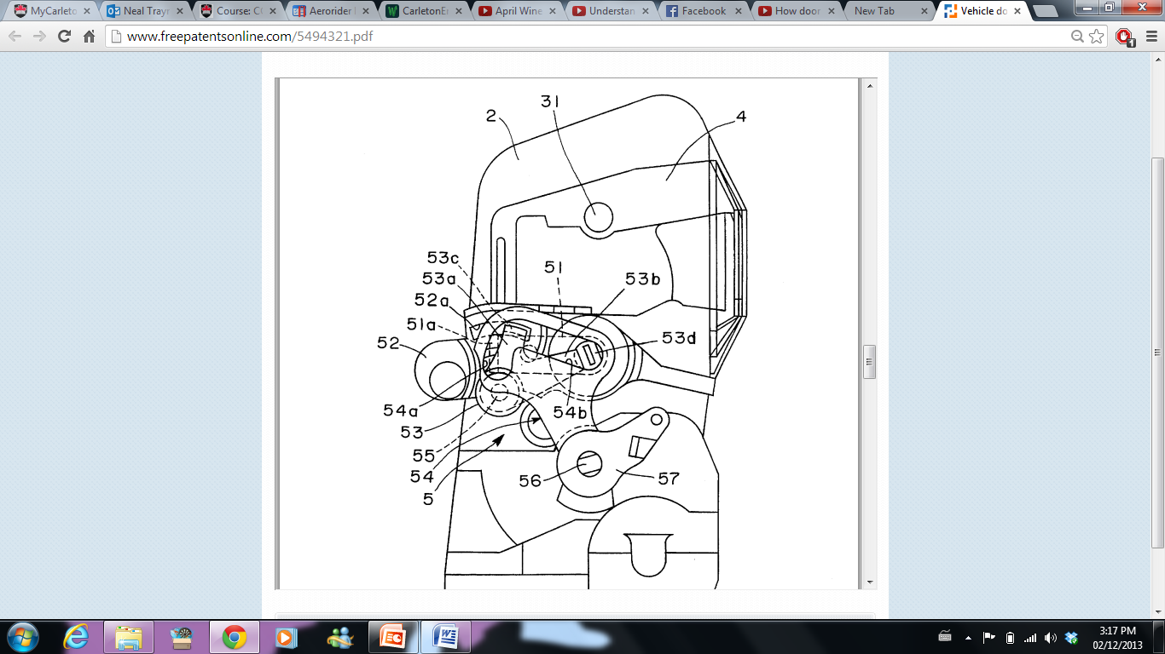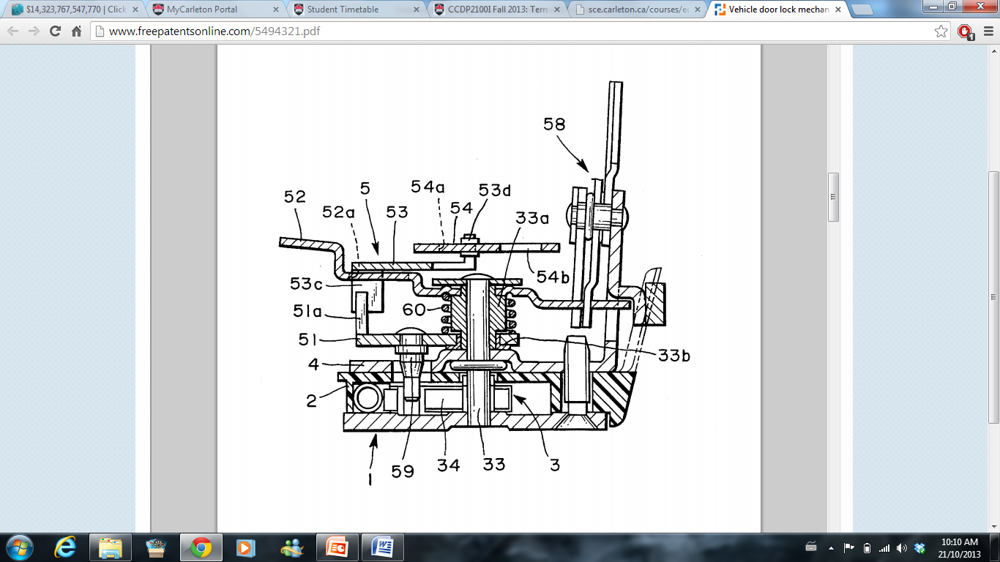Figure 1 shows the side view of the internal parts of this mechanism, while figure 2 shows the front view of the mechanism. The car door lock consists of two main parts: The female part and the male part. The male part is usually just a simple metal bar or hook, which would latch onto the female part. The locking mechanism inside the female part would then keep the two parts attached. As a result, having one part on the door and the other part on the frame of the vehicle would keep the door locked when the two parts are attached and the mechanism is functional. In the design used in our Vehicle, figures 1 and 2 show the female part, which will be attached to the frame of the vehicle. By turning the key, part 33 will twist, which will in turn rotate part 51, which will move part 34. Due to the unique door design of our Vehicle, much of the bulk of a traditional car door lock will be able to be eliminated. Figure 3 shows the complete mechanism of the traditional lock save the male part. Our design will eliminate most of the metal connection wirings that connect the locking mechanism to the door handle and manual lock. The male part in the Vehicle would be on the door itself, and the Female part will be on the frame. As a result of this, the bulk of the weight of the mechanism will be over the frame at all times, which will not interfere with Jacob's work on the force distribution of the Vehicle.

Figure 2: This is a front view of the mechanism.

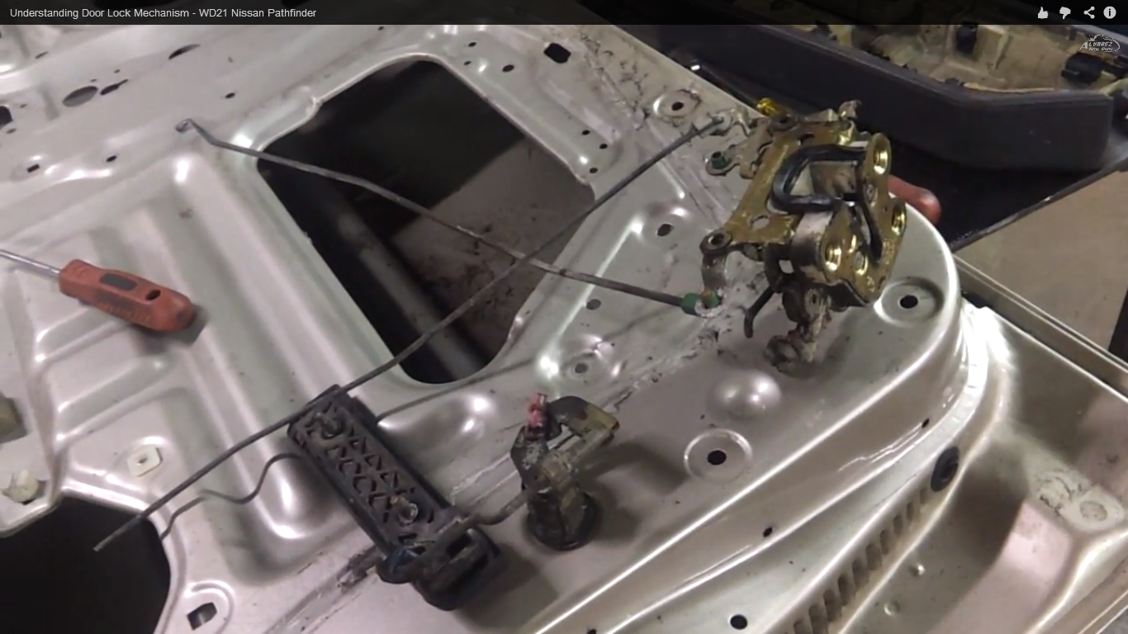

Figure 3: This is the complete locking mechanism for a Nissan PathFinder. Many of the metal wirings can be eliminated due to the design being centralized in a small area.

**3.4.2: SECONDARY OPTION**

The secondary option for the security of this Vehicle will be to use a standard bike lock and attach it to the back wheel of the Vehicle which is exposed. This will prevent the Vehicle from being wheeled or carried away. Due to the extreme light weight of the Vehicle, it is very possible that a group of friends could carry it away, or that one person could wheel it away like a wheelbarrow. The main problem with this option is the lack of availability of places to lock the Vehicle to. Until the Vehicle becomes widespread, many cities will not be willing to install bike racks on the side of the road specifically for the Vehicle which we are designing. As a result, this would hinder on the sale of the Vehicle because a less number of people would be willing to buy it if it comes with the "baggage" of needing to attach it to a bike rack or pole which might not be available.

**3.4.3: RECOMMENDATIONS**

The Recommendations for the security and locking mechanisms of the Vehicle are to use a Vehicle door lock for prevention of unwanted entry into the interior of the Vehicle. A bicycle lock will then be used as a secondary option to prevent the vehicle being moved or taken while the user is away. In this way the bicycle will have the best security possible while adhering to the three engineering parameters described earlier.

Figure 1: This is the side view of the internal parts of the mechanism.